Product Inventory Management System
Ideation Phase
Define the Problem Statements

Date | 26/02/2026
Team ID | 69aa7a6a630bbda4ae0afda3
Project Name | Product Inventory Management
Maximum Marks | 2 Marks

Customer Problem Statement Template:
The Customer Problem Statement helps identify the challenges faced by users while managing product inventories. Understanding the user's perspective allows the team to design a system that is secure, simple, and efficient. By analyzing user needs, the project focuses on creating a practical inventory management solution using the MERN stack.

Reference: https://miro.com/templates/customer-problem-statement/

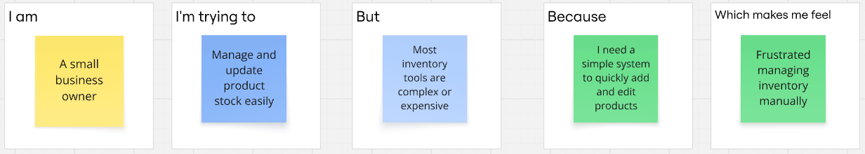
Problem Statement | I am (Customer) | I’m trying to | But | Because | Which makes me feel
PS-1 | A small business owner | Manage product stock efficiently | Existing tools are complicated or expensive | I need a simple system to add and update products quickly | Frustrated managing inventory manually
PS-2 | A freelancer selling products online | Track available items and pricing | Data gets lost without a centralized platform | I want a secure dashboard where only I can manage my products | Stressed about losing important product data
PS-3 | A shop manager | Update stock quantity regularly | There is no easy real-time CRUD system | I need a fast and responsive web app to update inventory anytime | Anxious when stock information is outdated
PS-4 | A new entrepreneur | Organize products in one place | Many inventory apps require complex setup | I want a lightweight and user-friendly inventory solution | Overwhelmed by complicated software

